**LIBRARY MANAGEMENT SYSTEM**

A library management is a project that manages and stores books information electronically according to user needs. The system helps both members and the library manager to keep a constant track of all the books available in the library. It allows both the admin and the student to search for the desired book. It becomes necessary for institution to keep a continuous check on the books issued and returned and even calculate fine. This task if carried out manually will be tedious and includes chances of mistakes. These errors are avoided by allowing the system to keep track of information such as issue date, last date to return the book and even fine information and thus there is no need to keep manual track of this information which thereby avoids chances of mistakes. Thus, this system reduces manual work to a great extent allows smooth flow of library activities by removing chances of errors in the details. Our management system has been made on

* **Key features of our library management system**

1. *New member signup:*

This makes our library management system completely automated as the person can anytime quickly signup and start his member with the library.

1. The system will show a note of weak password if the password entered consists of less than 9 alphabets.
2. A unique username will be assigned to the member after his signup is completed.
3. *Book issue and return with fine:*

With this system the administration can avoid all the paper work and chances of error as the complete process from issuing of the book to the return of the book becomes computer based.

1. A user cannot issue more than 5 books. In that case the system will not issue a book and will generate a note.
2. If the user returns the book after 14days from the date of issue, the user would be asked to pay a certain amount of fine.
3. *Book search:*

Searching of a book in a library is a tedious task, but with our library management system the user can search book.

1. The user can search the books on the basis of its genre, name of the book, or from the name of its author.
2. All the books related to the search made by the user would be displayed.
3. *Book request:*

If a book is not available in the library, then the user can send a request to the administration to add that book in the library.

1. *Lost and found:*

When you lose your belonging in the library it is very stressful and frustrating to ask the co-members or the staff or the administration if they found any thing left on the desk.

1. A administration personnel, member or a non-member can reach out here and report an item which they found left.
2. *Customer details:*

On signup of a new member his details would be directly added to the list of the customers specifying their name, address and date of birth.

* **With our library management system, the following benefits can be taken**

1. Reduction in paper work
2. Automation of library
3. Reduced chances of error
4. User friendly interface
5. Faster service
6. Easy to access resources

* **Screen shots of the outputs**

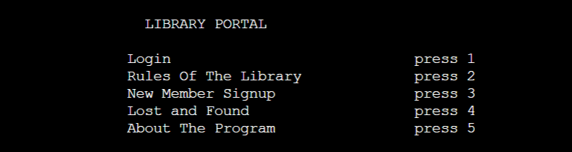

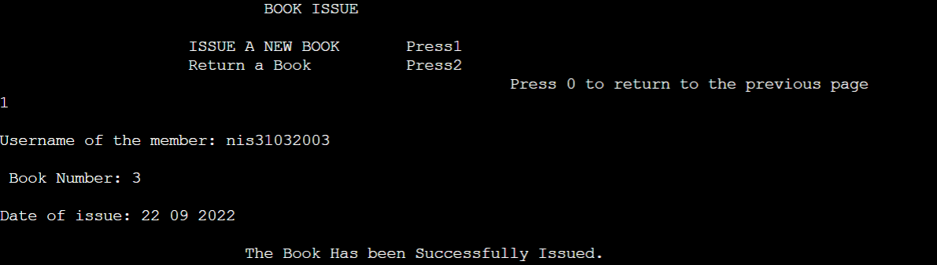

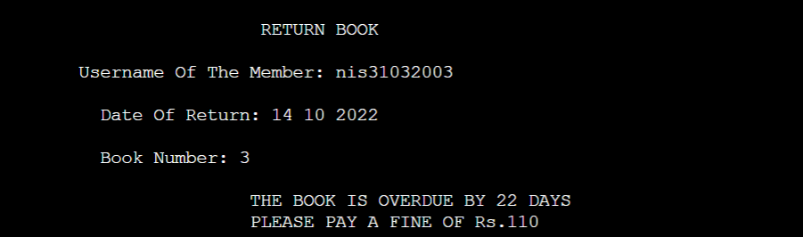

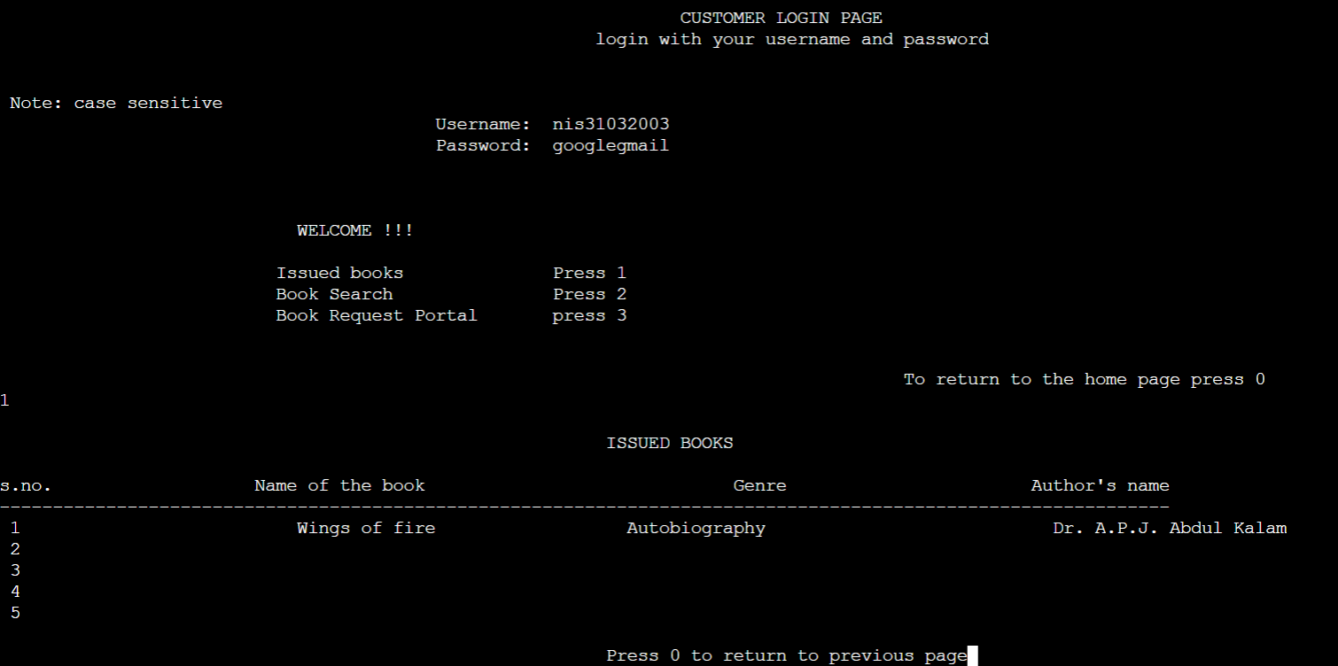

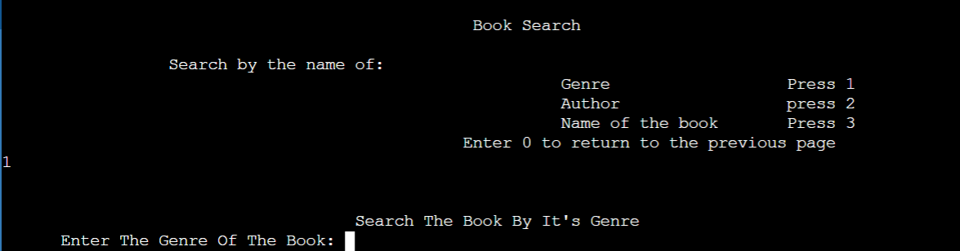

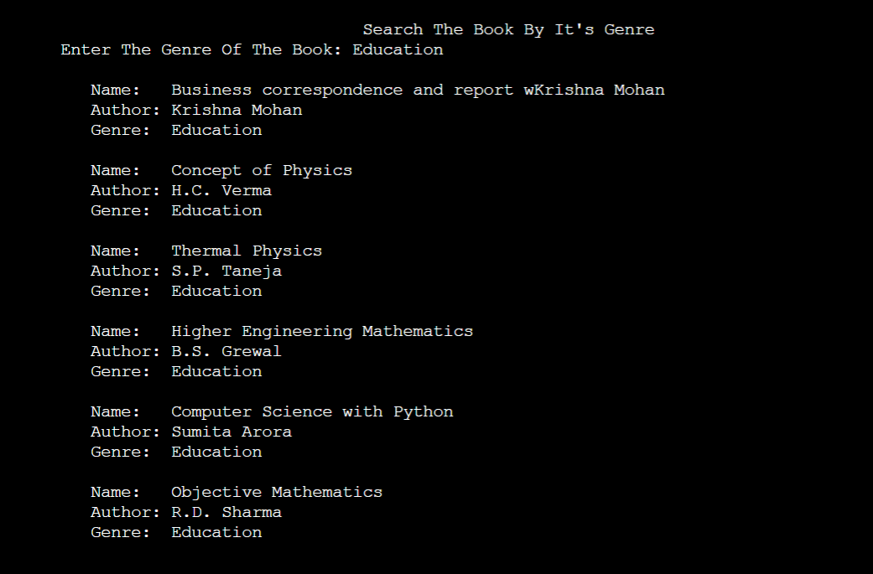

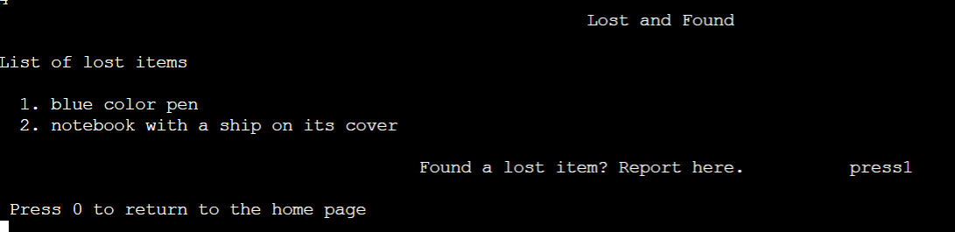

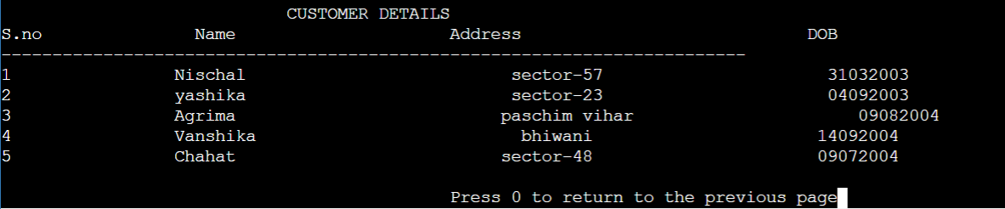

Project by:

Nischal Sharma